1. **Introduction**

**1.0 Description of the Development**

|  |  |  |
| --- | --- | --- |
| BUPT  number | Name | Responsibility |
| 2015213287 | Sun Wei | Group leader.  Several functions of back-end part: Login, Register, Product list, Product detail, Cart, Order. |
| 2015213297 | Ai Tianyi | The whole part of front-end, and the improvement of back end. |
| 2015213281 | Zhang Han | Several functions of back-end part: Login, Register, Order. |

*1.1 Project review：*

In addition to excellently completing the project according to teacher’s requirement (Version 1.0), we also take advantage of vacation time to perfect our project (Version 2.0).

Version 1.0 is aimed to complete basic functions. Due to the limited time, we choose to finish it with servlet & jsp framework.

After the improvement during vacation, the design idea of Version 2.0 is as follow: decouple at all levels, redesign back-end and front-end architecture, and achieve front and rear decoupling. In detail, for perfecting back-end development, we change the two-layer architecture into a three-tier architecture, from servlet-DAO to Controller-Service-DAO, thus implement decoupling with MVC architecture.

In aspect of front-end designing, asynchronous interaction is achieved with jquery and ajax besides jsp.

*1.2 Bright spot:*

In Version 1.0, not only do we finish basic functions, we also add extra functions to improve the user experience, such as “Forget your password” function and Modify user information function. Besides, we cannot satisfy with monotonous static web page, thus develop the project with ajex and jquery technology, taking advantage of asynchronous interaction to gain dynamic effects.

In Version 2.0, we choose advanced layered structure without traditional servlet structure. And to avoid potential security risk caused by Struts, we decide to use Spring MVC+Spring+Hibernate framework as an alternative of Struts+Spring+Hibernate.

Consequently, our project meet the requirements of enterprise - level java development in both in integrity and security. Besides, in our project, front-end asynchronous interaction is relatively flexible, the whole structure is explicit, and the code is readable.

*1.3 Business Process*

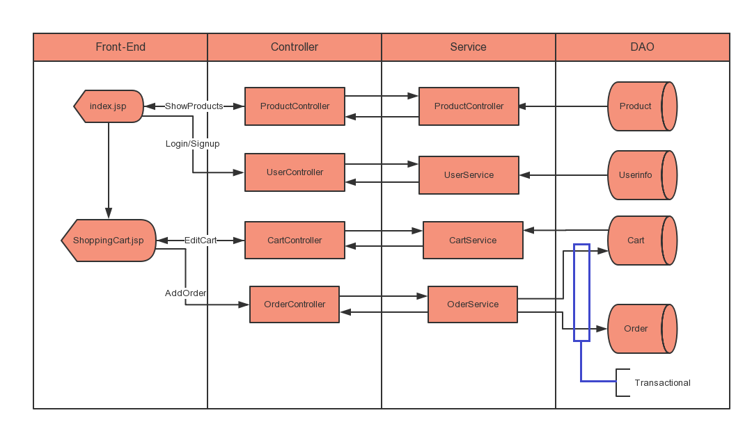

1. **Front-end design**

**Web pages**

1. Index page (homepage)

Show the navigation bar (including SERVICE, ROBOTS, TEAM, CONTACT and LOGIN choices) and the adverting video.



1. Product list page

When you click on the ROBOTS button in the navigation bar, it will automatically jump to the product list page, where the basic information (product name, unit price, and inventory) of all of our robots is shown.

1. 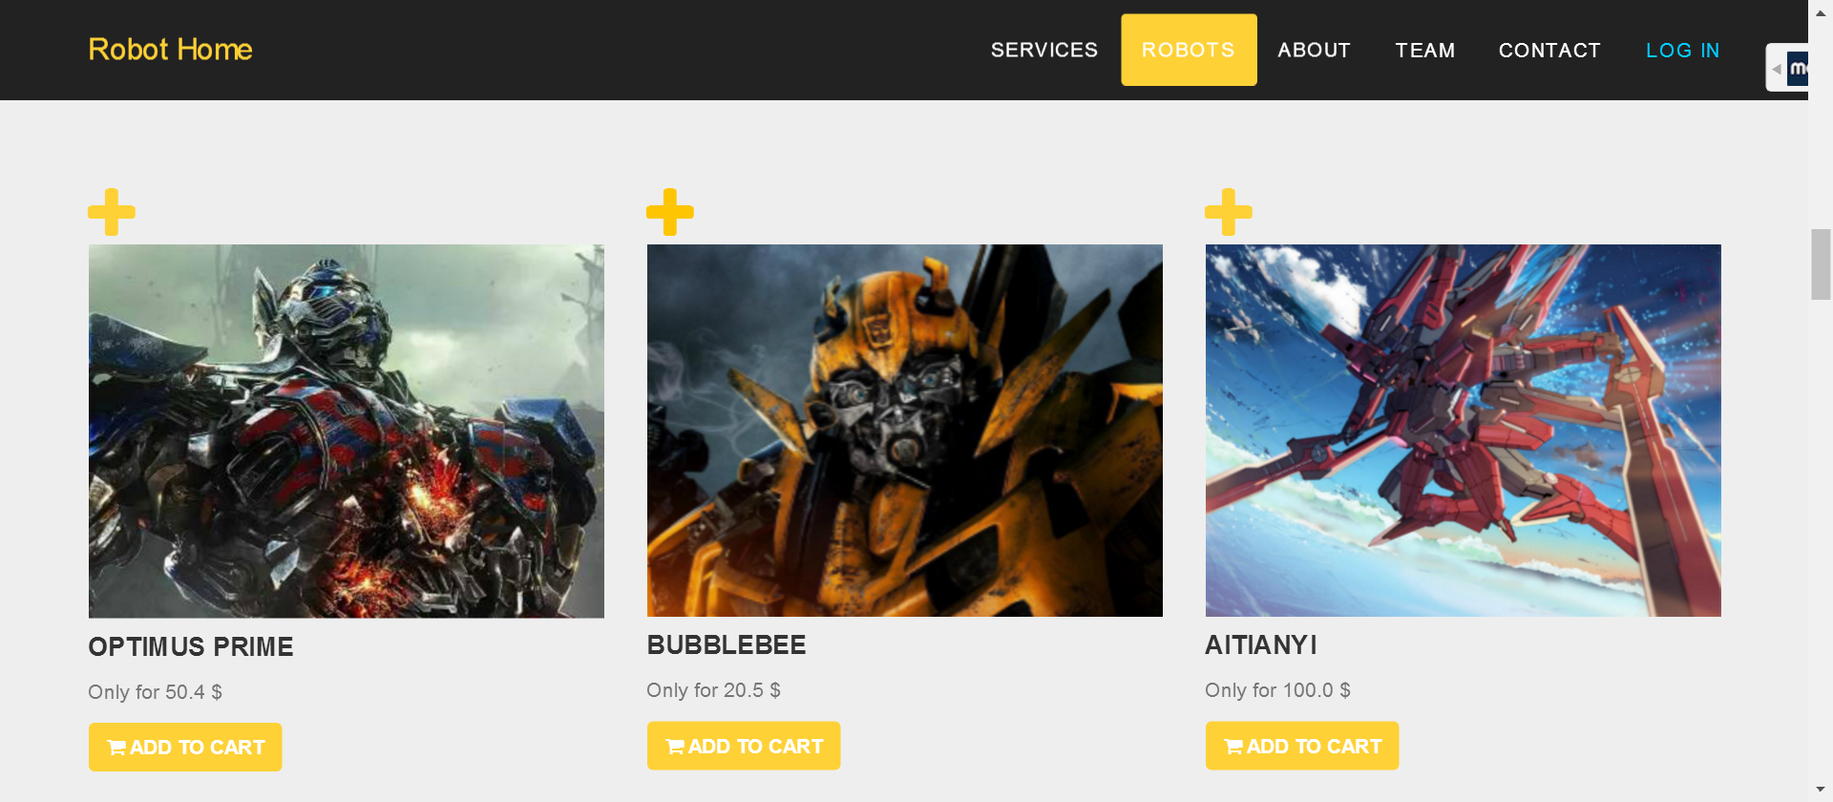Product detail page

After selecting a product from the product list page, you will come into the detail page of that robot, where you can find everything about the product and can choose to add some to cart or directly place an order (Make sure you have already logged-in).

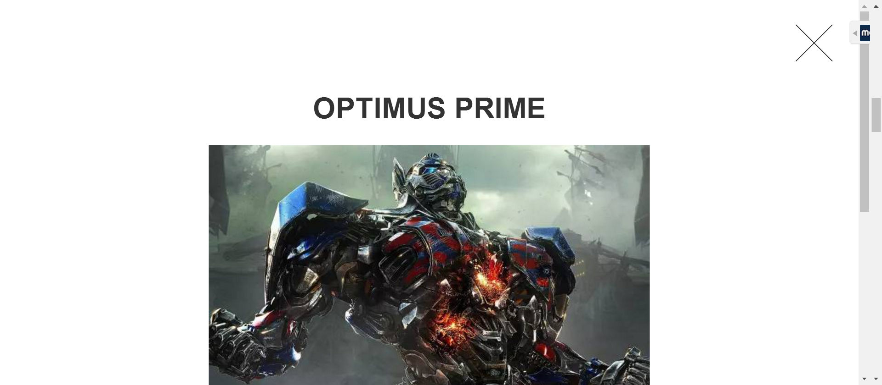

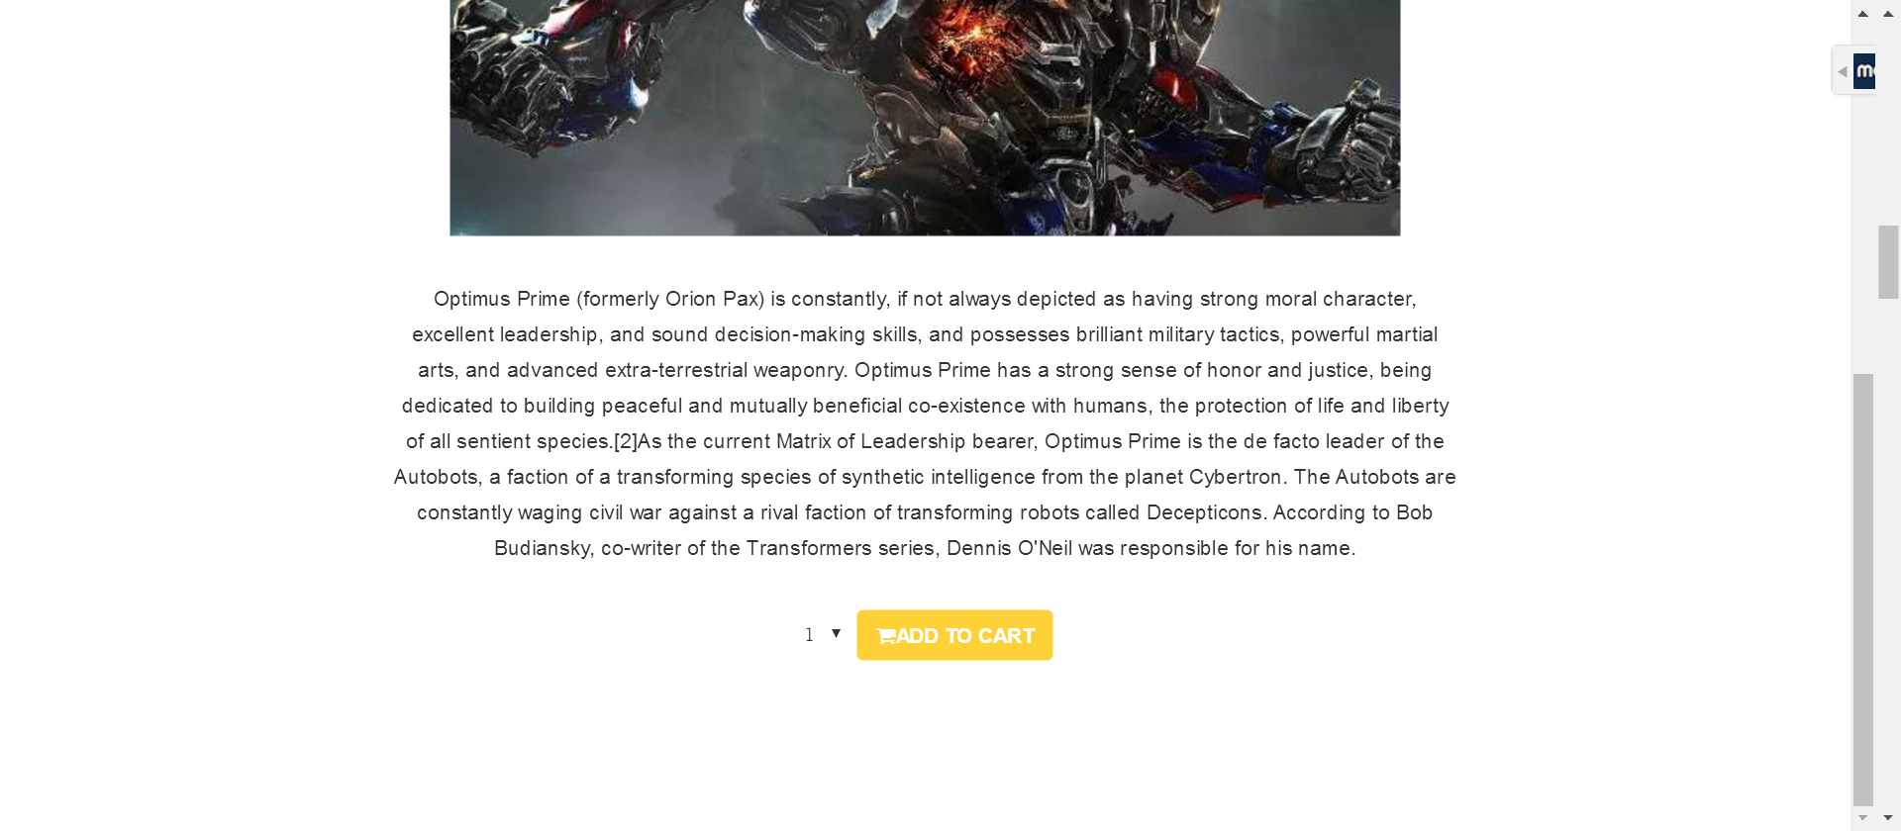

1. Login page

When you click on the LOGIN button in the navigation bar, it will automatically jump to the login page. If you already have an account, fill in the correct message according to the prompt box. If you forget your password, click on the FORGET PASSWORD button. As for new visitor, you can click on the REGISTER button to apply for a new account. Only if you are logged-in, the trade function can be accessed.

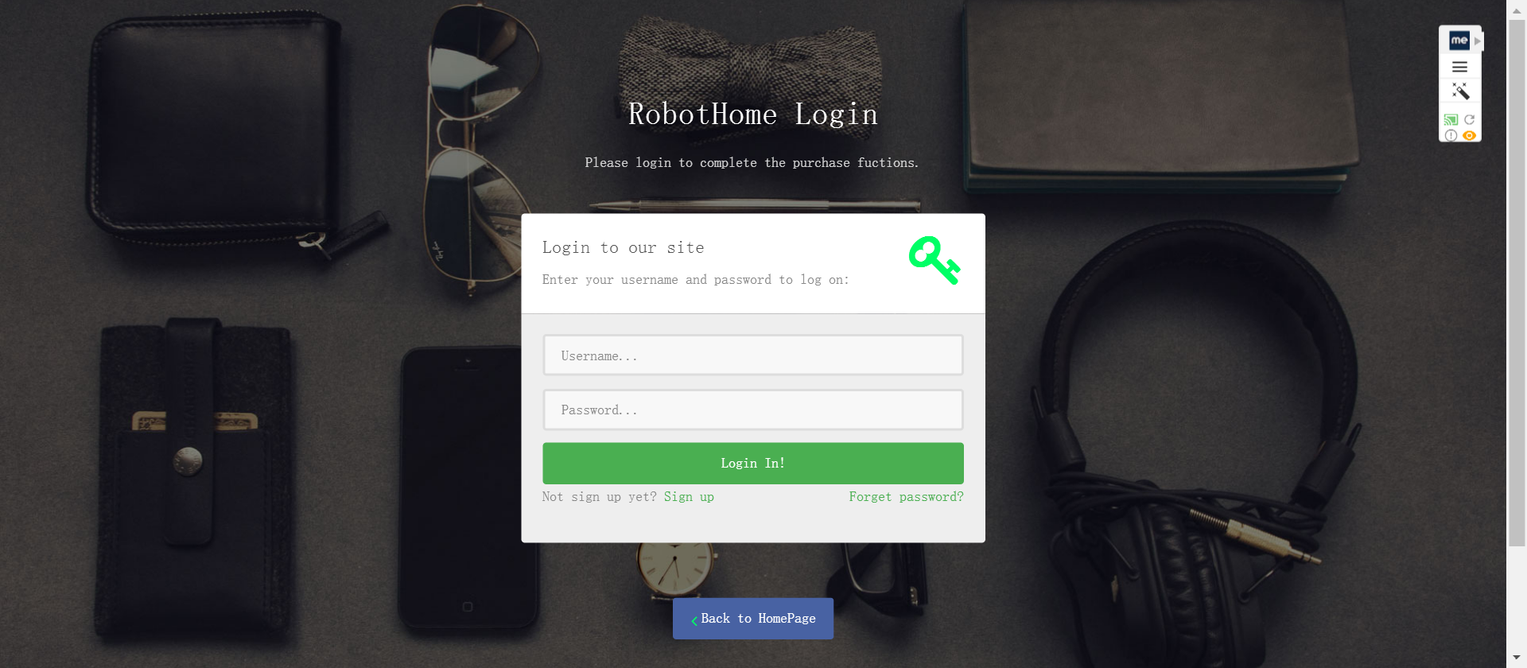

1. Register page

After filling in your username, password and e-mail address, you will gain a new account for free. If your information is legal (the username must be unique, if yours not, there will be message prompting you to change another one), it will jump to login page.

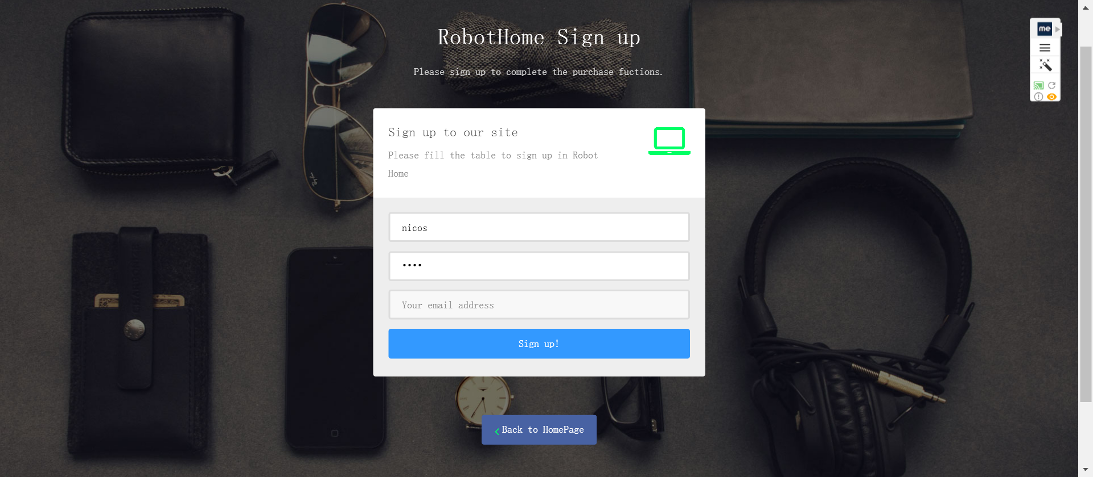

1. Modify user information page

If you want to modify your information, just re-enter it in this page. “forget your password” page

1. Fill in your username and your reserved e-mail to identify your identity. If correct, you can modify your password and back to log in your account.
2. 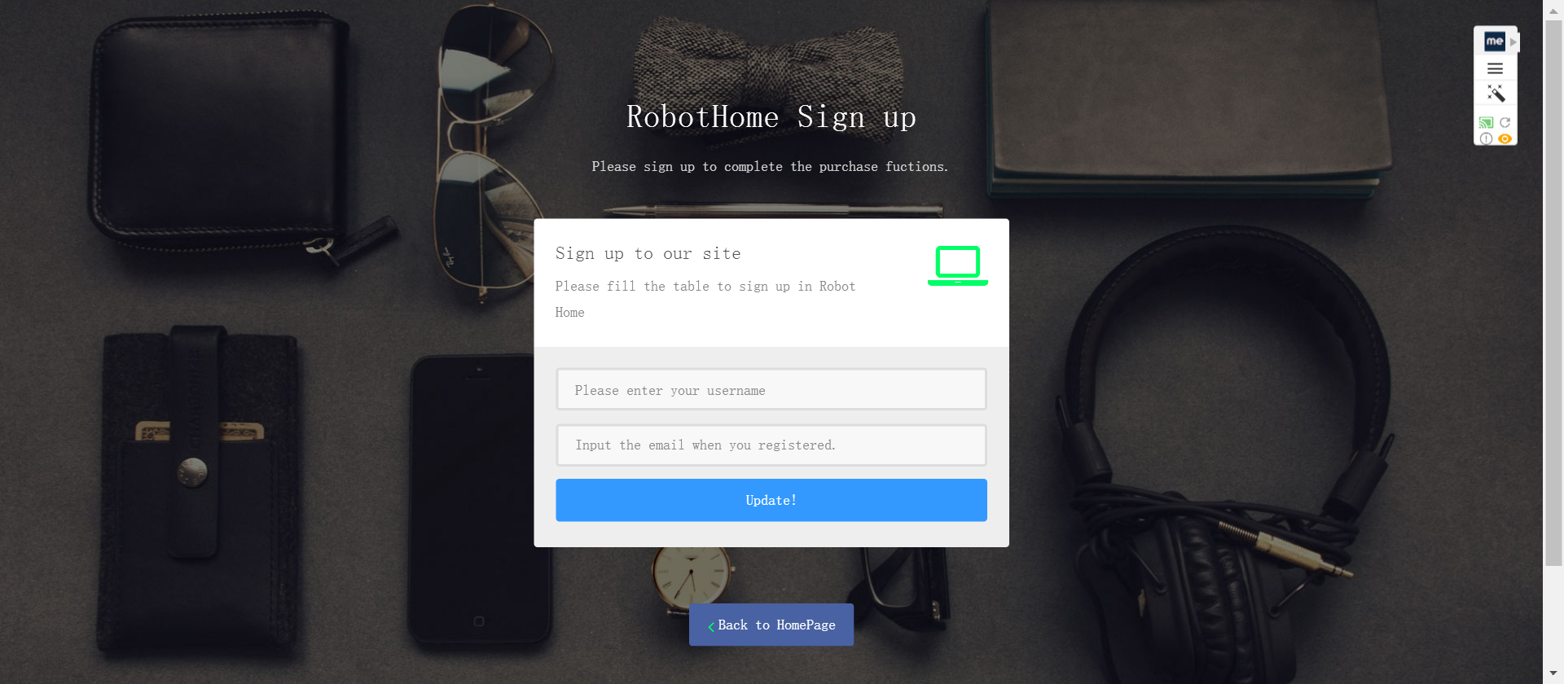Cart page

The cart page will show your cart information, including the product name, quantity, unity price, and the total price of your cart. You can choose some to place an order or delete some of them from the cart.

1. 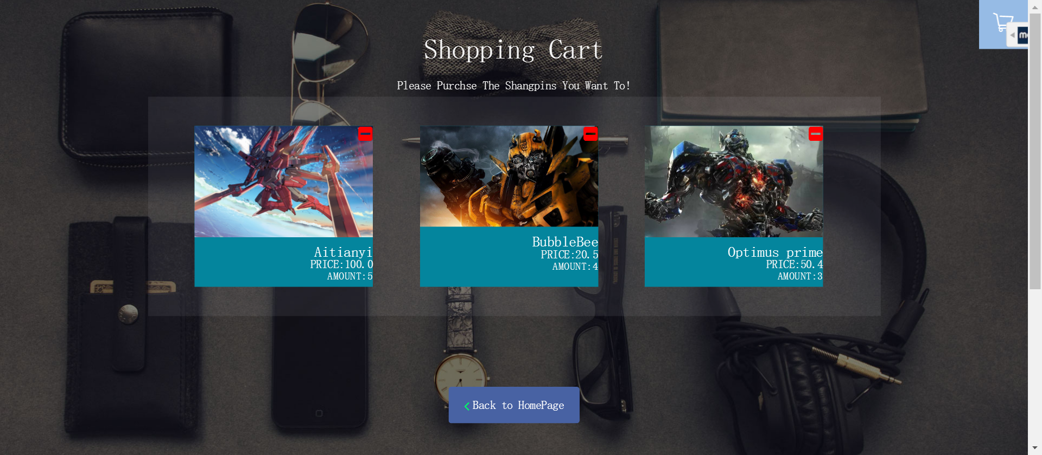Order page

You are shown the information of your order, including unique order number, product information and total price. If everything is alright, you can purchase it.

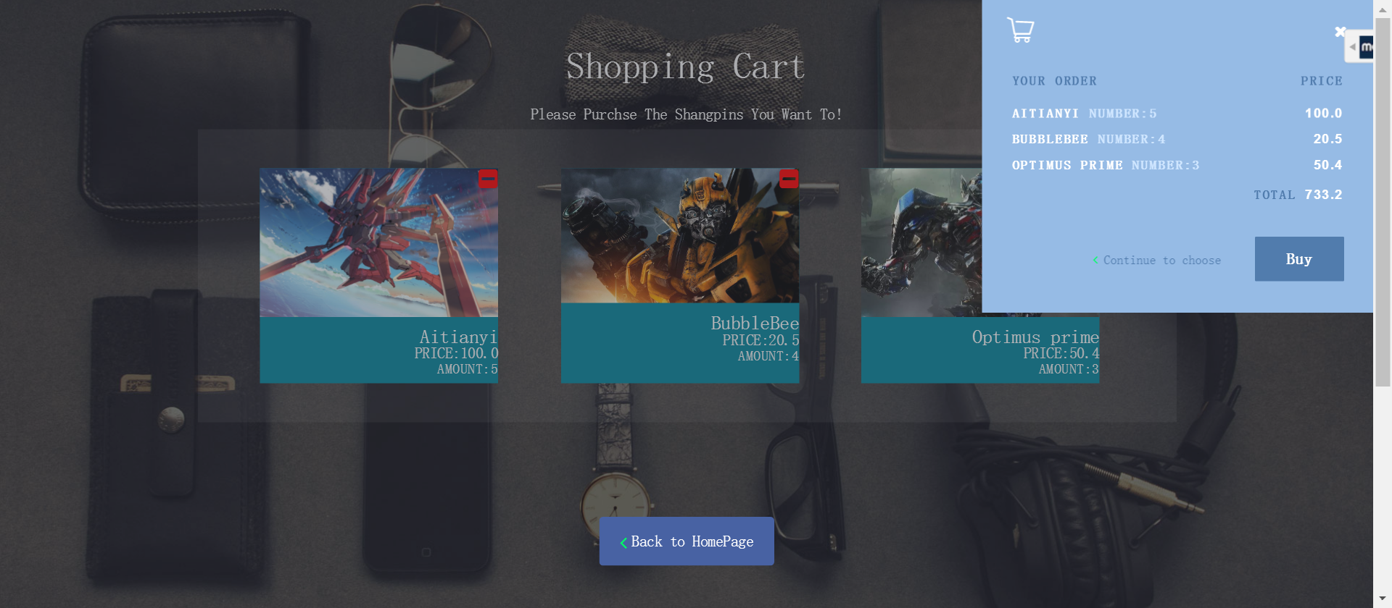

1. **Back-end**

**Version 1.0**

1. Package structure

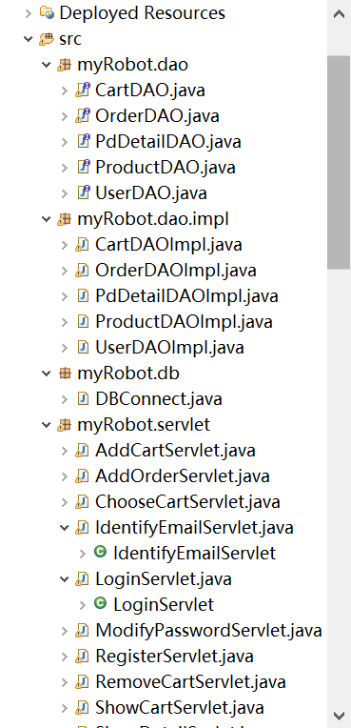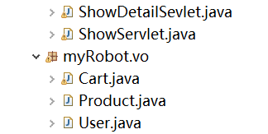

1. Use of technology

JSP+SERVELT

Version 2.0

1. Package structure

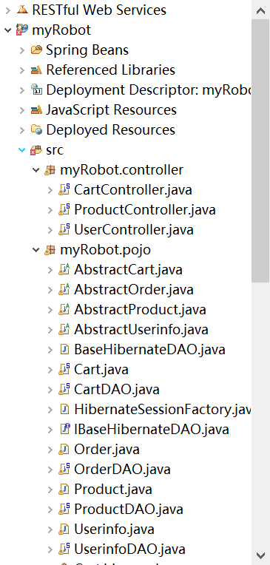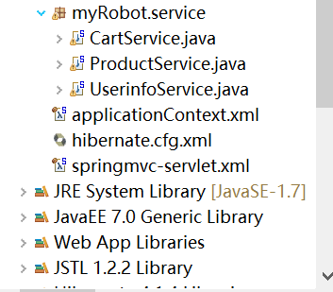

1. Use of technology

Background: Spring MVC+Spring+Hibernate

Front-end: Jsp

**3 main functions**

1. User information part
   1. Registration & Login function

In the Index-interface, the pop-up dialog window will remind unregistered visitors to log in and the page will jump to the Login-page automatically. User can choose either to log in or to register a new account in the Login-interface.

* 1. Modify user information function(Extra)

If the password is forgotten, user can find it back via verify identity information. The page use vue to render asynchronously, effective and useful.

* 1. “Forget your password” function (Extra)

It is similar to the registration function. In contrast, user need to re-enter personal information, and the data will be persisted.

1. Product information part
   1. Display product list & detail function

By DOM element rendering, the product list, showing basic information and linking to product detail page, is added to the Index-page.

To provide data on the home page, welcome-file is placed in a Controller. After completing the data preprocessing stage, the data will be returned as a ModelAndView object, and then come into the Index-page for front-end rendering.

* 1. Search product function

In the Index-page, user can perform a fuzzy keyword search based on their demand. If successful, it will jump to the modal box. If not, it will be the dialogue window.

1. Trading part
   1. Generate a cart function

In the Cart-interface, user can choose whatever product they want, and also can delete whatever product they don’t want by clicking the “delete button” in the upper right corner of the product.

During the delete process, the RESTful API call DAO to delete the product. Then , after making asynchronous request, the detail page will be re-rendered.

* 1. Place an order function

There will be three steps while placing an order:

1. Delete all the products in the current cart

2. Generate an unique order number and add the information of these products into the order list

3. Determine whether the former steps are completed. If true, the order number will be returned to the front end to render and the Order information will be persisted.

* 1. Purchasing function

User can choose to purchase any product in the homepage or the detail page.

Once the purchase is complete, the amount and information of the product will be sent back to Controller, and the Cart form will be persisted in Hibernate.

1. **Database**

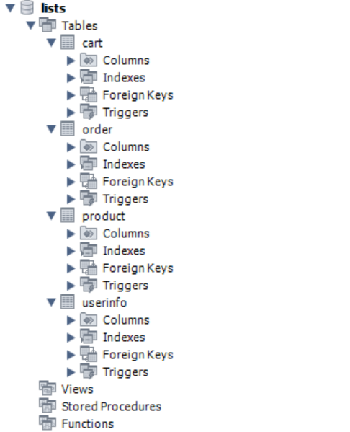

There are four tables in the database:

Table ‘userinfo’ is used to storage user information, including unique user ID, username, password and e-mail address. When user register an effective new account, there will be a new record added to the table. When user want to log in, only if the fill-in password matches the information looked up from the table, it will succeed. When user want to modify their information, look up the table to find the user and revise the information.

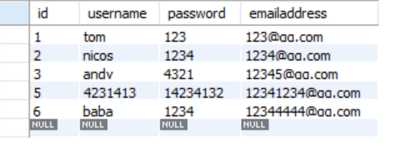

Table ‘product’ is used to storage all the product information, including unique product ID, product name, quantity and unit price. The table is mainly used for looking up to show the product information on the page.

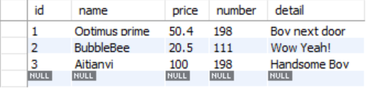Table ‘cart’ is used to storage the information of user’s cart, including unique user number, user name, unique product ID and the quantity user want to buy. Besides adding, the record of the table can be deleted when user want to delete something from the cart.

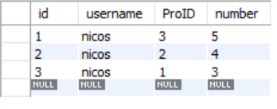

Table ‘oder’ is used to storage the information of user’s order, including unique user number, user name, unique product ID, the quantity user want to buy, and the unique order number. The table can be added, deleted and looked up.

